**Meeting Contents**

We all agreed that we will plan to meet in person twice a week. On the whole this will be on Monday and Friday. We chose this because by meeting on Monday it allows us to set-up for the week, and allows us to share what we have done over the weekend; and on Fridays it allows us to go over what we went through in the week, and set-up what we will each do over the weekend. There will be situations where we are unable to stick to these days and so we may have a meeting on another day in a particular week.

Meeting 1 – Friday 31st January 2020

**We discussed how the game could work: (Our initial ideas)**

* Users will be put into groups based on their personal tutors
  + Split in half – so 5/6 per group
  + One-login per team – so only need one phone
* At the top of the page, there will be blank spaces that make up the final location – hangman style
  + The final location being the building where their tutor is
* There will be a QR Code at each location which students must scan to confirm they are at that particular location
* By scanning the QR code, you will be given a question to answer
  + You may be able to ask for a hint if you are unable to answer it
  + Some questions will be location specific, and others will be generic
* Successfully answering the question will mean a letter from the final location will be given
* The students will have access to all of the locations from the get-go
* There will be a stopwatch from the moment the students scan the first QR code for timing purposes
* Once the team has successfully completed every location, the room of their tutor will be revealed
  + Thus, groups must finish the game before being able to find their tutor
* There will be a real-time leader board for the gamekeeper to see, which is based on the number of letters each group has obtained so far
* For the extra information such as FAQs, useful information and room locations in buildings, we could implement it as a chat-box

**We discussed the types of questions we may ask:**

* Cheapest pint in the RAM
* How many seats in a lecture hall

**We discussed the different locations we could use:**

* Library
* Ram
* Forum Auditorium
* Harrison
* 207
* 004
* Sports Park
* Peter Chalk
* Innovation Centre
* Great Hall

Meeting 2 – Monday 3rd February 2020

**We discussed potential “could haves”:**

* Time deduction for a using a hint
* Having team members names as part of a team (could have)

**We discussed the role of the gamekeeper:**

* Gamekeeper has username and password to sign in
* Gamekeeper Functionalities:
  + Gamekeeper can create a game
  + Gamekeeper can only create one game at a time
  + Gamekeeper can print off relevant QR codes for the game
  + Can upload a game file for the relevant subject
  + Can view the leaderboard

**We discussed details of the game from a back-end/database point of view:**

* Each game has a unique gameID
* Team has a unique name within that game
* There will be NO password for each game
* 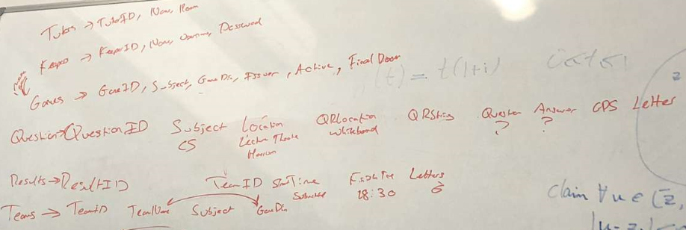We realised we needed to add a number of new tables which we started to generate on a whiteboard

Meeting 3 – Friday 7th February 2020

**We collectively made changes to our UI designs:**

* We moved the useful information onto the main homepage (not logged in)
  + It ensures that the users don’t have to be in a game to look at the useful information
* Our prior UI design assumed that you had to be within an active game to look at the useful information section

**We went through the Kanban Board together:**

* Looked at the Kanban board to see our progress
* Went through what we have individually done by looking at the tickets
  + We made sure that everyone understands what each other have done and made sure everyone knows the code that is going on
* We had a look at the different cards in the backlog and picked the ones we are going to take on next

**We went through the MVC framework:**

* We have chosen to use the Model-View-Controller framework throughout our project
* As a group we then had to go over the framework and discuss how it works
  + It is important to make sure everyone understands the framework before substantial code is written

**We discussed issues that we are having:**

* There were certain “Must have” cards that we could not do until another card had been completed
  + For example: Ravi was working on implementing the tutor selection process for team registration, but this was only possible once the reading of config files was verified. A gamekeeper selects a config file, and the system should extract the data so that it inserts the data from the file into the database. Thus, only once this feature was completed could Ravi do his implementation and fully test it

Meeting 4 – Tuesday 11th February 2020

**We discussed what we had completed since the last meeting:**

* Having had the weekend, we had made good progress
  + For example: we had completed the sign-up page and the admin creating a new game
* Like other meetings, we made sure everyone understood what each other had done and the code that is associated with it

**GitHub branch merging and validation:**

* As a group, we chose to use GitHub and within our development, we often go into different branches
  + As a result, when merging back into Master, there can be conflicts
* There was a couple of merge issues that we had and as a group we went through them to solve it
  + We had communicated over social media with these conflicts, but it proved to be a bit more difficult, so we chose to wait until this meeting to solve it
* Whilst we were all together, we collectively completed some validation
  + For example: we validated Harry’s FAQ page and the new design pages to include tutor information

**Future steps to finish Sprint 1:**

* As this was our last meeting before the first sprint submission, we went over what is left to do
* We all decided to record our 1 minute showcase video to collate tomorrow into one video
* In terms of documentation, we set tasks to ensure that it is all ready for submission

Meeting 5 – Tuesday 18th February 2020

**We reflected on the group meeting:**

* We reflected on the group meeting we had with Matt last Friday
* Based on the feedback, we started to incorporate work units into our Kanban Board
  + We agreed that 1 Work Unit = 1 Hour of Work
  + We started to put these into our cards
* We also went through what we worked on since the last meeting

**We discussed any difficulties we were having:**

* We discussed an issue Freddie was having with the QR scanning card
  + To help, Ben said he will work with him on it

**We thought about extra features:**

* We realised that there should be features to incorporate those with disabilities so that the application is more usable to more people
  + One of the features we thought of was having the ability to have the program read out the question to the team – this will help with those who have slight vision issues
* We assigned cards to each person, so that everyone knows what they are doing for the next meeting

Meeting 6 – Friday 21st February 2020

**We went through the meeting we had with Matt:**

* We went over in more detail the meeting we had just had with Matt
* We reflected on what Matt said about where to improve from the first sprint
  + We made notes of these, such as introducing work units and creating user manual

**We went over the Kanban Board:**

* We went over the Kanban Board for what work will be done over the weekend
* We have had other coursework which we have been focussing on and so we checked the Kanban Board to see what we have left to do for Sprint 2
* We assigned cards again and went over the cards which we will have to do

Meeting 7 – Monday 24th February 2020

**We discussed what we did over the weekend and earlier in the day:**

* As mentioned in the last meeting, we wanted to make sure we had a very productive weekend and so we went over the work we had done
* Adam was having trouble with his leaderboard card and so as a group we spoke about what the best approach would be
* Earlier in the day, Ben and Ravi had finalised a new hosting solution and so we went through how that works
  + We agreed that we will have a separate deployment branch on GitHub, which we will update on Thursday when the next release (Sprint 2) version comes out
  + The hosting solution automatically updates itself from the contents of the branch which we set (our deployment branch)
* We have the scanner able to read and interpret QR Codes, whilst producing the question associated with it in the webpage console
  + We went over the questions we will ask and whether they will be multiple choice or single answers
    - We opted for a mixture, but discussed that we must make it such that if the user has to input text, all possible cases are dealt with (such as lower/upper)

**We discussed the Kanban Board:**

* We discussed the cards that are left for this sprint in detail
  + Some cards we knew were unable to be performed until something else was completed, but other cards were assigned to members so that they could work on them
* We validated cards as a group, some of which required everyone’s attention

**We discussed the steps needed until Sprint 2 submission:**

* We discussed the documentation needed – mostly product documents that we still had to do after our meeting with Matt last week
  + Such as the user manual
* Our next release would be on Thursday